Psychology and Aging

© 2025 American Psychological Association
ISSN: 0882-7974

2025, Vol. 40, No. 8, 913–928
https://doi.org/10.1037/pag0000927

Age Differences in Spatial Navigation Stem From a Preference for Familiar Routes Rather Than Impaired Landmark-Dependent Strategies

Paul F. Hill1, Skyelynn Bermudez1, Joshua D. Garren1, Andrew S. McAvan2, Jingyi Zheng3, Carol A. Barnes1, 4, and Arne D. Ekstrom1, 4
- Department of Psychology, University of Arizona
- Department of Psychology, Vanderbilt University
- Department of Mathematics and Statistics, Auburn University
- Evelyn F. McKnight Brain Institute, University of Arizona

A leading hypothesis in the ﬁeld of aging and navigation is that older adults are selectively impaired on tasks that require allocentric (landmark-based) strategies to navigate, resulting in a shift toward more egocentric (self-based) strategies. However, most evidence in humans comes from studies that restrict body-based sensorimotor cues that are essential to both egocentric and allocentric navigation. In the present study, young and older adults navigated a virtual environment in each of two conditions: a stationary desktop condition that relied on visual input and an immersive condition that enabled unrestricted ambulation and sensorimotor feedback during navigation. Both age groups performed worse when initially learning locations from novel compared with familiar locations—often considered a hallmark of allocentric nav-
igation. The cost of switching from familiar to novel start locations was equal between age groups, pointing to a null effect of age on allocentric strategies. Older adults also employed distal landmarks to a comparable extent to young adults, suggesting that landmark-dependent strategies did not differ by age. However, older adults were more likely to replicate previously taken paths, potentially indicative of a preference for egocentric strategies. The path replication effect was signiﬁcantly attenuated in the immersive condition, particularly in the presence of geometric boundary cues that could be used to infer distance. Age differences in spatial navigation may therefore be driven in part by a selective bias for navigating familiar routes, although these differences were lessened in the presence of multimodal visual and sensorimotor cues. The present study highlights that navigation is a complex cognitive construct that draws on multiple parallel systems and strategies that cannot be easily explained by a simple allocentric–egocentric dichotomy.
This document is copyrighted by the American Psychological Association or one of its allied publishers.
This article is intended solely for the personal use of the individual user and is not to be disseminated broadly.
All rights, including for text and data mining, AI training, and similar technologies, are reserved.

Public Signiﬁcance Statement
Spatial navigation, which is essential for well-being and independence, declines during healthy aging. A prevailing hypothesis is that impaired navigation in older age stems from selective deﬁcits in allocentric- based wayﬁnding strategies. In the present study, we used advanced virtual reality techniques to reveal that age-related differences in spatial navigation are more nuanced and likely arise from a combination of factors rather than being solely attributable to impairments in allocentric navigation.

Keywords: spatial navigation, aging, allocentric, egocentric, virtual reality Supplemental materials: https://doi.org/10.1037/pag0000927.supp

This article was published Online First August 28, 2025. Hannes Zacher served as action editor.
Paul F. Hill https://orcid.org/0000-0002-9983-0842
De-identiﬁed data and analysis scripts are posted on https://osf.io/5vbzn/. The ideas and data appearing in this article have previously been dissem- inated in a preprint (https://doi.org/10.31234/osf.io/b7n6s). This research was supported by the Alzheimer’s Association (Grant AARF-22-926755) awarded to Paul F. Hill and National Institute on Aging, National Institutes of Health (Grant R01AG003376) awarded to Carol A. Barnes and Arne D. Ekstrom.
Paul F. Hill played a lead role in data curation, formal analysis, investi- gation, project administration, validation, visualization, and writing–original draft, a supporting role in funding acquisition, and an equal role in concep- tualization and writing–review and editing. Skyelynn Bermudez played a

supporting role in data curation, investigation, and project administration. Joshua D. Garren played a supporting role in investigation and project administration. Andrew S. McAvan played a lead role in software and a supporting role in conceptualization and writing–review and editing. Jingyi Zheng played a supporting role in formal analysis, software, and visual- ization. Carol A. Barnes played a lead role in funding acquisition and an equal role in writing–review and editing. Arne D. Ekstrom played a lead role in methodology and resources and an equal role in conceptualization, funding acquisition, supervision, writing–original draft, and writing– review and editing.
Correspondence concerning this article should be addressed to Paul F. Hill or Arne D. Ekstrom, Department of Psychology, University of Arizona, 1503 East University Boulevard, Tucson, AZ 85721, United States. Email: paulhill@arizona.edu or adekstrom@arizona.edu

913

914
This document is copyrighted by the American Psychological Association or one of its allied publishers.
This article is intended solely for the personal use of the individual user and is not to be disseminated broadly.
All rights, including for text and data mining, AI training, and similar technologies, are reserved.

HILL ET AL.

Past research suggests that successful navigation of new spatial environments declines with healthy aging, although the reasons for this ﬁnding remain unresolved (Lester et al., 2017). Spatial navi- gation is often considered to rely on two complementary strategies. Allocentric or “placed-based” navigation requires learning the relationships between external spatial cues, such as landmarks or environmental boundaries, which in turn are thought to underlie the computation of novel and more efﬁcient routes. Egocentric or
“route-based” navigation involves self-reference to landmarks and typically relies more on traveling familiar, well-learned routes and is often considered to be less ﬂexible and efﬁcient than allocentric navigation. One hypothesis in the ﬁeld of aging is that allocentric-based navigation is impaired in older age, resulting in a preference for more egocentric-based navigation strategies
(Colombo et al., 2017; Iaria et al., 2003; Li & King, 2019; Moffat et al., 2006).
The ability to form a cognitive map of the environment, which is central to most models of allocentric navigation, is generally believed to involve the integration of external (e.g., landmarks, boundaries) and body-based (e.g., motor efference copy, proprioceptive, vestib- ular) sensory cues (Campbell et al., 2018; O’Keefe & Nadel, 1978; Siegel & White, 1975). Prior studies in humans, however, have relied overwhelmingly on experimental paradigms that require participants to navigate a two-dimensional virtual reality (VR) environment rendered on a computer monitor (Daugherty et al., 2015; Iaria et al., 2009; Moffat & Resnick, 2002; Moffat et al., 2007; Zhong et al., 2017). These types of “desktop VR” paradigms rely pri- marily on visual input while restricting the types of body-based sensory cues that are central to allocentric and egocentric forms of spatial navigation. Experimental studies employing desktop VR can also be confounded by age differences in prior experience with using a joystick or keyboard and mouse to navigate a ﬁrst-person virtual environment. Finally, many of these studies do not directly test how landmarks are integrated during body and head movements. A critical gap in the literature, therefore, concerns whether age differences in navigation strategies persist when body-based cues are available to support navigation (McAvan et al., 2021).
Age differences in allocentric navigation may also be dependent on the types of visual cues available within the environment. Human studies of spatial navigation often require participants to learn the relationships between discrete landmarks, such as a unique building or street sign. There is growing evidence, however, that older adults may be selectively disadvantaged at using these types of visual landmarks to orient in space (Colmant et al., 2023; West et al., 2023). Instead, older adults may be more adept at using spatial cues that convey the relative lengths, distances, and angles between large- scale surfaces within the environment, such as walls or walkways. Studies employing these types of geometric spatial cues have shown that older adults are just as likely as younger individuals to orient using putative allocentric search strategies (Bécu et al., 2020, 2023). An overarching aim of the present study, therefore, was to examine the extent to which age differences in navigation strategy pre- ferences are affected by the availability of enriched visual and body- based sensorimotor cues.
The Morris water maze (MWM) task is a commonly used assessment of allocentric navigation and spatial memory (Morris et al., 1982). Originally developed for rodents, the MWM task involves learning the locations of hidden objects within an envi- ronment surrounded by distal landmark cues. Successful performance

on the task requires participants to learn and subsequently remember the location of hidden objects with reference to the distal cues, which is generally considered to depend on externally referenced allocentric memory processes. Virtual adaptations of the MWM task developed for human participants and administered on a desktop computer have been used extensively to examine putative allocentric navigation abilities in aged humans. Older adults are consistently observed to remember locations with respect to distal landmarks less accurately than do younger individuals on the MWM task (Daugherty & Raz, 2017; Daugherty et al., 2015; Hill et al., 2024; Iaria et al., 2009; McAvan et al., 2021; Moffat & Resnick, 2002; Moffat et al., 2007; Zhong et al., 2017). By contrast, older adults are generally observed to perform just as well as younger individuals during conditions in which visual cues indicate the location of a previously “hidden” target (i.e., visible platform trials).
When employing the MWM and other spatial tasks, however, it is important to note that allocentric and egocentric navigation strat- egies are difﬁcult to isolate and common behavioral measures often involve a combination of strategies and spatial reference frames
(Ekstrom et al., 2014; Johnsen & Rytter, 2021; Wolbers & Wiener, 2014). In the present study, we considered multiple measures of putative allocentric navigation to reduce the potential inﬂuence of this issue. One such measure involves manipulating the familiarity of the navigation start positions such that participants are cued to locate hidden targets from familiar (i.e., well-learned) and novel locations (Eichenbaum et al., 1990; Kolarik et al., 2018; McAvan et al., 2021; Wolbers & Wiener, 2014). The assumption is that performance on familiar and novel start trials should be relatively similar in those individuals using an allocentric reference frame to infer the location of a hidden target. By contrast, those individuals who rely more heavily on an egocentric reference frame should perform reasonably well when taking a well-learned route from a familiar start position but show reduced performance when navi- gating from a novel start position, which places a greater emphasis on the distal landmark cues.
In the present study, we examined the impact of enriched visual and body-based sensory cues on spatial memory as young and older adults navigated a virtual MWM environment (Figure 1). Participants were trained to ﬁnd the locations of hidden targets in a virtual outdoor environment in each of two VR conditions: a desktop VR condition that required using a keyboard and mouse to navigate and an immersive and ambulatory VR condition that enabled unrestricted self-motion during navigation (see Hill et al., 2024). We employed a version of the virtual MWM in which four distal landmarks were clearly visible outside of the navigable space in all environments. We tested older and young adults on memory for a hidden target location from both a novel and familiar (repeated) start location during both acquisition and delayed probe trials.
On a subset of delayed probe trials, we rotated one of the distal mountain cues to test participant reliance on the stable three mountain cues or the single (moved) mountain. Greater reliance on the single moved mountain cue might suggest a greater reliance on a beaconing strategy. In a subset of participants (N = 48), a circular boundary was located outside of the navigable arena to serve as a geometric spatial cue (Figure 1B). Critically, the distal mountain cues and circular boundary wall were in- tended to convey unique sources of spatial information during navigation. Whereas the distal mountain cues could be used to

AGING AND SPATIAL NAVIGATION STRATEGIES 915

Figure 1
Virtual Morris Water Maze Task Design

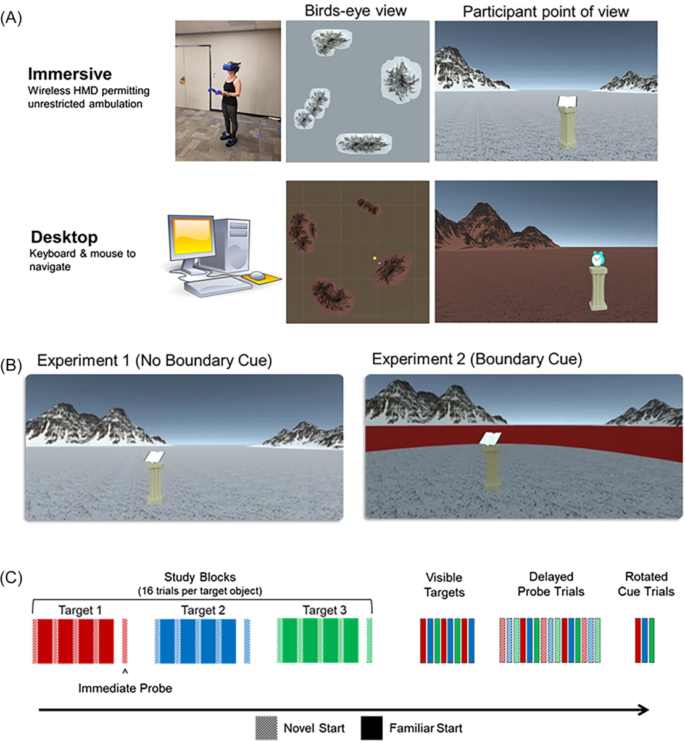
This document is copyrighted by the American Psychological Association or one of its allied publishers.
This article is intended solely for the personal use of the individual user and is not to be disseminated broadly.
All rights, including for text and data mining, AI training, and similar technologies, are reserved.

Note. (A) Visual depiction of the immersive and desktop virtual reality conditions. The assignment of the respective environments (snow, desert) to each virtual reality condition (desktop, immersive) was fully counterbalanced across
participants, as was the testing order of the respective conditions. (B) First-person depiction of the available spatial cues in the no boundary (distal mountains only) and boundary (distal mountains and perimeter wall) conditions. (C) During the spatial acquisition blocks, participants were trained to locate the spatial positions of three hidden target objects (color coded). Immediately following each spatial learning block, participants were cued to recall the location of the hidden object without feedback (immediate probe trials). Following the learning blocks, participants completed eight visible target trials to rule out potential age-related motivational and/or sensorimotor confounds. Participants completed 12 delayed probe trials without feedback, during which they were cued to locate the hidden target when starting from a familiar (solid bars) or novel (dashed bars) location. In a subset of the delayed probe trials, a singular mountain cue was rotated 20° clockwise or counterclockwise unbeknownst to the participant. Figure adapted from
“Age Differences in Spatial Memory Are Mitigated During Naturalistic Navigation,” by P. F. Hill, S. Bermudez, A. S. McAvan, J. D. Garren, M. D. Grilli, C. A. Barnes, and A. D. Ekstrom, 2024, Aging, Neuropsychology, and Cognition, 31(6), p. 1110 (https://doi.org/10.1080/13825585.2024.2326244). CC BY 4.0. HMD = head mounted display. See the online article for the color version of this ﬁgure.

infer relative directions within the otherwise featureless envi- ronment, the circular boundary was meant aid in the estimation of relative distances within the navigable environment. The experimental design therefore allowed us to test whether age

differences in navigation strategies are differentially affected by the inclusion of geometric spatial cues (boundary vs. no boundary) and/or body-based sensory cues (immersive VR vs. desktop VR).

916
This document is copyrighted by the American Psychological Association or one of its allied publishers.
This article is intended solely for the personal use of the individual user and is not to be disseminated broadly.
All rights, including for text and data mining, AI training, and similar technologies, are reserved.

HILL ET AL.

Materials and Method Transparency and Openness

We report exclusionary criteria and describe all manipulations and measures that were collected. De-identiﬁed data and analysis code are available from the ﬁrst author upon request, and a link to these materials is provided in the author note (Hill, 2025). The study design and analysis procedure were not preregistered. The data presented here were also presented in a previous article with a focus on the impact of virtual testing modality on age differences in spatial memory (Hill et al., 2024). The focus of the current article is instead on testing hypotheses related to spatial strategy and age, an issue not covered in the previous article. The descriptions of the participant information and VR procedures overlap heavily with the descrip- tions given in that report and are partially summarized here. The analyses and behavioral ﬁndings described below are novel and have not been reported previously.

Participants

We recruited 45 young and 46 older adults from the University of Arizona and surrounding communities. Participants were recruited in two separate waves to be enrolled in the no-boundary (20 young, 20 older) and boundary (24 young, 24 older) versions of the MWM task (see the Procedures section). One older adult voluntarily with- drew from the study due to a scheduling conﬂict; one young and one older adult withdrew after experiencing mild motion sickness during the VR task. The ﬁnal participant sample included 44 young adults (18–31 years; M = 21.50 years; SD = 3.23; 27 females) and 44 older adults (63–80 years; M = 70.48 years; SD = 4.89; 21 females). The ﬁnal sample size (N = 88) was informed by an a priori power analysis conducted in G*Power employing between-repeated measures. The sample was selected to ensure power of 0.85 (at p < .05) to detect Medium Age Group × VR Condition interactions
( f = .25) in a 2 (age group) × 2 (VR condition) analysis of variance (ANOVA). Given the novelty of our study design, we elected to perform a power analysis based on a conservative (medium) effect size estimate to avoid underestimating the sample size needed to detect a meaningful two-way interaction. A chi-square analysis conﬁrmed that the distribution of gender did not signiﬁcantly differ between the young and older adult groups (χ2 = 1.14, p = .285). All participants gave informed consent in accordance with the University of Arizona’s Institutional Review Boards and were compensated at the rate of $18 per hour. All participants had normal or corrected-to-normal color vision and normal or corrected-to- normal hearing and reported no history of cardiovascular problems, neurological conditions, or motion sickness.
All older adult participants completed a neuropsychological test battery on a day prior to the experimental VR session. The test battery included multiple tests and scores in each of ﬁve broad cognitive domains: memory (California Verbal Learning Test–II Long Delay Free Recall, Delis et al., 2000; Rey–Osterrieth Complex Figure Test Long Delay Free Recall, Rey, 1941), executive function (Trail Making Tests A and B total time; Reitan & Wolfson, 1985), language (F-A-S ﬂuency, Spreen & Benton, 1977; category ﬂuency, Benton, 1968; Boston Naming Test, Goodglass et al., 2001), visuo- spatial abilities (Wechsler Adult Intelligence Scale 4th edition Block Design Test, Wechsler, 2009; Rey–Osterrieth Complex Figure Test copy score, Rey, 1941), and verbal intelligence (Wechsler Adult

Intelligence Scale 4th edition Vocabulary and Similarities; Wechsler, 2009). Participants were excluded from entry into the study if they scored greater than 1 SD below age-appropriate norms on any memory test or greater than 1 SD below age norms on any two other tests. These criteria were employed to minimize the likelihood of including older individuals with mild cognitive impairment (Bondi et al., 2008; Jak et al., 2009). Scores on the neuropsychological assessments did not differ between older adults enrolled in the boundary and no-boundary conditions (Supplemental Table 1). Older adults in the respective boundary and no-boundary condi- tions also did not differ in years of education obtained, t(40.98) = −0.45, p = .657 (boundary, M = 17.42 years, SD = 2.02; no
boundary, M = 17.65 years, SD = 1.42).

Procedure

Participants performed virtual adaptations of the MWM task. The virtual environments and experimental tasks were built in Unity 3D (Unity Technologies ApS, San Francisco, California) using the Landmarks VR navigation package (Starrett et al., 2021). All participants performed the task in each of two virtual conditions. In the immersive VR condition, participants were equipped with a wireless head mounted display (HTC Vive Pro Eye) and a handheld HTC Vive controller. This setup was used to simulate an immersive experience of being in a mountainous environment while simul- taneously allowing for unrestricted locomotion and body-based sensory cues during navigation. Participants also completed an analogous version of the task on a desktop computer while seated in a behavioral testing room. This desktop VR condition required using a keyboard and mouse to navigate the two-dimensional environment. The order of the respective immersive and desktop VR conditions was fully counterbalanced across all participants. Additional technical speciﬁcations for the respective VR conditions are described by Hill et al. (2024).
Each virtual environment was rendered with a unique ﬂoor (snow covered or desert, counterbalanced across the respective desktop and immersive VR conditions) and four distally rendered mountains located on the horizon. These distinctive renderings were meant to reduce interference and potential carryover effects from the preceding virtual session such that participants would treat the two environments independently. The navigable environment in both the desktop and immersive VR conditions was approximately 5 × 5 m in size, with the full visible space spanning approximately 750 × 750 m. A subsample of young (N = 20) and older (N = 20) adult participants performed a version of the task in which the distal mountains were the sole source of spatial information within the environment (i.e., no-boundary condition). A separate sample of young (N = 24) and older (N = 24) adult participants completed an identical version of the task apart from a circular wall (20 m in diameter) placed around the perimeter of the navigable space in addition to the four distal mountain cues (i.e., boundary condition).
Participants were trained to learn the location of three hidden objects placed at ﬁxed positions within the 5 × 5-m navigable space. Each virtual environment was associated with three unique 3D rendered objects (book, Rubik’s cube, teapot in the snow-covered environment; alarm clock, mug, rotary phone in the desert envi- ronment). The objects were presented on pedestals at approximately chest height. Participants completed 16 consecutive learning trials for each target location. Prior to each trial in the immersive VR condition,

AGING AND SPATIAL NAVIGATION STRATEGIES 917
This document is copyrighted by the American Psychological Association or one of its allied publishers.
This article is intended solely for the personal use of the individual user and is not to be disseminated broadly.
All rights, including for text and data mining, AI training, and similar technologies, are reserved.

the headset displayed a blank screen while an experimenter guided the participant along a random path for 30 s. This disorientation phase was meant to prevent participants from tracking their locations and movements from the previous trial. A similar disorientation phase was included in the desktop VR condition, during which participants viewed a blank screen for 30 s before starting the next trial.
Following the 30-s disorientation, participants were placed at one of eight predetermined starting positions. Each block of 16 study trials was organized into four subblocks, each corresponding to a unique start position (e.g., four consecutive trials from Position 1, followed by four consecutive trials from Position 5). Each study trial began with visual instructions indicating the navigation goal (e.g.,
“Please ﬁnd the book”). Participants then freely navigated while searching for the hidden object that remained invisible for the ﬁrst 30 s of the trial.
To encourage spatial learning, participants were instructed to remember the ﬁxed positions of the hidden objects and to navigate to this location and respond via button press before 30 s had elapsed. This button press was treated as a spatial memory response, and the location and timestamp of the response were recorded in the data
output. Upon making a response, the object became visible to permit spatial updating during the study trials. If a button response was not
made, the target object would appear after 30 s, and the participants’ location at the time the object became visible was logged in the data
output. At the end of each 16-trial spatial learning block, participants were placed in a novel start position and instructed to navigate to the location of the hidden target (immediate probe trials). Unlike the immediately preceding study trials, the object did not appear after 30 s, nor did the object appear upon making a button press.
Following the three study blocks, participants completed one block of eight visible target trials. During these trials, objects were placed in their original studied locations and remained visible for the entire duration of the trial. This was meant to serve as a control for motivational and sensorimotor differences while performing the task
(Moffat & Resnick, 2002; Morris et al., 1982). The results of the visible target trials are summarized in the Supplemental Materials and described in more detail by Hill et al. (2024).
After completing eight visible target trials, participants performed 12 delayed probe trials to assess delayed spatial recall of the hidden target locations. As with the immediate probe trials, the target object did not appear after 30 s nor did it appear after a button press. Participants were thus required to navigate to the location of the hidden target object based solely on their memory. Upon reaching this location, participants made a button press to record their location and timestamp. In a separate set of three delayed probe trials (one trial for each hidden target object), we rotated the position of a single mountain cue 20° clockwise or counterclockwise to assess potential age differences in the relative use and weighting of distal landmark cues during navigation (see Analytic Approach). For these trials, we rotated the mountain with an angular orientation closest to that of the hidden target object when standing in the center of the arena. This was done to ensure the mountain was clearly visible when facing the hidden target location.

Analytic Approach

Position and rotation data were recorded throughout the entire experiment at a sampling rate of approximately 10 Hz. All statistical analyses were conducted with R software (R Core Team, 2022). All

t tests were two-tailed and performed using the t.test function in the base R package. Welch’s unequal variance t tests were performed when assumptions of equal variance were not met. Multiple regression analyses were conducted using the lm function in the base R package. ANOVAs were conducted using the afex package (Singmann et
al., 2016), and the Greenhouse–Geisser procedure (Greenhouse & Geisser, 1959) was used to correct degrees of freedom for non- sphericity when necessary. Post hoc tests on signiﬁcant effects from the ANOVAs were conducted using the emmeans package
(Lenth, 2018) and corrected for multiple comparisons using the Holm-Bonferroni procedure where appropriate. Bayesian mixed- effects regression models for circular data were performed using the bpnme package in R (Cremers et al., 2018). Unless otherwise speciﬁed, we report the results of three-way mixed-factorial ANOVAs with between-subject factors of age group (young, older) and cue type
(boundary, no boundary) and the within-subject factor of VR condition (desktop, immersive). Bayes factor values (BF10) were computed using the BayesFactor package (Morey et al., 2022) and interpreted using the categorical labels proposed by Jeffreys (1961).

Switching Between Familiar and Novel Routes

During the study phase, young and older adult participants were trained to learn target locations by navigating from ﬁxed locations within the respective virtual environments. These locations were organized in a blocked format such that each starting location was repeated over four consecutive trials for a given target before moving to a novel start position and repeating this process for the same target. This blocked format was meant to ensure participants learned a speciﬁc start location by having participants repeatedly navigate from this location. Participants were therefore cued to recall hidden target locations from familiar (i.e., previously learned) and novel start positions. Prior studies have employed familiar and novel start positions as an assay of egocentric and allocentric navigation
strategies, respectively (Eichenbaum et al., 1990; Kolarik et al., 2018; McAvan et al., 2021; Wolbers & Wiener, 2014).
We tested whether older adults would show greater “switching costs” when taking a novel compared with a familiar route to locate the hidden target (Harris & Wolbers, 2014; Harris et al., 2012), a proxy for egocentric navigation strategies. Spatial memory was operationalized as the Euclidean distance (in virtual meters) between the remembered and true location of each target object (i.e., spatial distance error). To maximize route familiarity, performance on familiar trials was computed as the mean distance error on the fourth consecutive trial initiated from a given location within the envi- ronment (i.e., the fourth and ﬁnal trial of each block). Performance on novel trials was similarly computed as the mean spatial distance error on trials immediately following each familiar trial (i.e., the ﬁrst trial of the next block, including immediate probe trials).
We also examined whether young and older adults differed in their tendency to replicate familiar, previously learned paths when switching to a novel start position. We reasoned that participants preferring more of an egocentric or route-based strategy would tend to replicate familiar paths even when navigating from a novel start
position. This should result in greater familiar-to-novel path simi- larity compared with those preferring a more allocentric strategy
(Iggena et al., 2023). We quantiﬁed path replication as the spatial distance between navigation paths taken on consecutive familiar
(i.e., fourth and ﬁnal trial of a given block) and novel (i.e., ﬁrst trial

918
This document is copyrighted by the American Psychological Association or one of its allied publishers.
This article is intended solely for the personal use of the individual user and is not to be disseminated broadly.
All rights, including for text and data mining, AI training, and similar technologies, are reserved.

HILL ET AL.

of the next block) trials. Navigation paths were deﬁned as the vector of XY coordinates of the VR headset over the duration of a given
trial. Consecutive paths were aligned to obtain a common starting coordinate (0, 0). To account for differences in path length, we used a nonlinear dynamic time warping algorithm to ﬁnd the optimal match between each respective pair of navigation trajectories using the dtw package in R (Giorgino, 2009) function. This analysis thus yielded a measure of dissimilarity between respective paths, with higher scores indicating less similarly (or more allocentric) and lower scores indicating more similar trajectories (or more egocentric).

Landmark-Based Navigation During Delayed
Probe Trials

Successful allocentric navigation requires encoding the spatial relationships between stable landmarks within the environment. One possibility is that older adults are less likely than young adults to orient toward the distal mountain cues when attempting to locate the hidden target. To examine this possibility, we computed the trial- wise angular difference between participant heading at the time of retrieval (button press) during the delayed probe trials and the heading error for each of the respective distal mountain cues, yielding four estimates of landmark error. Landmark error was computed separately for each of the respective distal mountain cues (yielding four land- mark error estimates). For each trial, we identiﬁed the smallest of the four landmark error estimates and used these values as the dependent variable in a mixed-effect regression analysis. This approach was motivated by the assumption that the most salient distal cues used to orient within the environment would yield the smallest angular distance error. We similarly computed the trial-wise angular differ- ence between participant heading at retrieval and the correct heading of the hidden target object (target error). Target and landmark error values could thus range from 0° to 360°.
We used Bayesian mixed-effect regression models for circular data (Cremers et al., 2018) to examine whether young and older adults differed in their tendency to orient toward the distal mountain cues and/or hidden target during the delayed probe trials (Cremers &
Klugkist, 2018; Du et al., 2023). We constructed separate models for landmark and target error. For each model, we entered heading error (transformed to range from −180° to 180° then converted to radians) as the dependent variable. Age group, VR condition, and cue type were entered into the model as ﬁxed-effect predictors, and by- subject intercept terms were entered as random effects (angular error – age group + subject). We used the bpnme package in R
(Cremers, 2020) to run a Bayesian Markov chain Monte Carlo sampler with 1,000 iterations for the mixed-effects model to calculate the posterior estimates of the landmark and target errors for each age group, VR condition, and cue type, the circular means, and 95% higher posterior density (HPD) interval of the respective angular error estimates.
We next examined the subset of probe trials in which a single distal mountain cue was rotated 20° clockwise or counterclockwise. We computed the distance error between a given object’s remem- bered location and the hypothetical location of that object if it were rotated 20° commensurate with the rotated mountain cue (rotated error). We then divided the rotated error by the sum of the rotated error and the true distance error between the estimated and true (unrotated) location of that target object: error index = rotation error/(rotation error + true error). Values approaching 0 signify greater weighting

of the rotated mountain cue (i.e., beacon strategy), and values approaching 1 indicate greater weighting of the three stationary mountain cues (i.e., allocentric strategy). Due to a programming error, the direction (clockwise vs. counterclockwise) of the cue rotations was not properly recorded in the desktop condition. Analysis of the rotated mountain cues was therefore restricted to the immersive VR condition.

Results
Older Adults Do Not Show Selectively Worse Performance Compared With Young Adults When Finding a Hidden Target From a Novel Start Location Compared With a Familiar One

The ability to switch between familiar and novel routes to locate hidden targets is often used as a proxy for allocentric navigation strategies in the MWM task (Eichenbaum et al., 1990; Kolarik et al., 2018; McAvan et al., 2021; Wolbers & Wiener, 2014). Here, we tested whether older adults would show worse performance com- pared with young adults when navigating to the hidden target from a novel start position compared with a well-learned and familiar start position within the environment. To this end, we submitted the mean distance error during the acquisition trials to a four-way mixed- factorial ANOVA with factors of age group (young, older), VR condition (immersive, desktop), cue type (boundary, no boundary), and start position (novel, familiar). This analysis revealed a sig- niﬁcant main effect of start position, F(1,84) = 60.47, p = 1.7−11, partial η2 = .419, BF10 = 78.546. Post hoc tests conﬁrmed that this effect was driven by increased distance error when starting from a novel start position compared with starting from a familiar start
position, t(84) = −7.78, p < .001.
Critically, the interaction between age group and start position was not signiﬁcant, and a Bayes value suggested strong evidence in favor of the null hypothesis, F(1,84) = 0.46, p = .499, partial η2 =
.005, BF10 = .167. The respective interactions between start position and VR condition, F(1,84) = 1.49, p = .226, partial η2 = .017, BF10 =
.183, and between start position and cue type, F(1,84) = 1.24, p =
.269, partial η2 = .015, BF10 = .197, were also nonsigniﬁcant, with strong Bayes evidence in favor of the null hypothesis. Indeed, familiar versus novel effect size estimates were largely similar for young and older adults across the respective VR and cue type conditions (see Table 1). These ﬁndings suggest that older adults are not selectively impaired when attempting to locate the hidden target from a novel start location compared with young adults.
During the delayed probe trials, participants were prompted to locate each of the respective hidden targets from memory fol- lowing a delay while navigating from novel start locations (i.e., starting locations not encountered during the spatial learning phase). On a subset of delayed probe trials (two of 12 total trials), participants were prompted to locate the hidden target when starting from a familiar location encountered during the spatial learning phase. We submitted the mean distance error during the delayed probe trials to a four-way ANOVA with factors of age group (young, older), VR condition (immersive, desktop), cue type (boundary, no boundary), and start position (novel, familiar). The four-way ANOVA revealed a signiﬁcant main effect of start position, F(1,84) = 114.91, p = 5.7−16, partial η2 = .578 which, in contrast to the study trials, was driven by greater distance error when starting

AGING AND SPATIAL NAVIGATION STRATEGIES 919
This document is copyrighted by the American Psychological Association or one of its allied publishers.
This article is intended solely for the personal use of the individual user and is not to be disseminated broadly.
All rights, including for text and data mining, AI training, and similar technologies, are reserved.

Table 1
Mean Distance Error (With Standard Error) When Navigating From Familiar and Novel Start Positions

Young adult

Older adult
Condition

Familiar

Novel

t value

Familiar

Novel

t value

Study trials
Immersive, boundary | 0.99 (.11) | 1.22 (.11) | −3.13** | 1.53 (.11) | 1.78 (.11) | −3.32**
Immersive, no boundary | 1.62 (.12) | 2.03 (.12) | −5.15*** | 2.44 (.12) | 2.71 (.12) | −3.34**
Desktop, boundary | 0.82 (.16) | 1.03 (.18) | −2.05* | 2.54 (.16) | 2.72 (.18) | −1.82
Desktop, no boundary | 1.78 (.18) | 2.02 (.19) | −2.20* | 3.44 (.18) | 3.66 (.19) | −2.03*
Delayed probe trials
Immersive, boundary | 1.59 (.15) | 1.25 (.12) | 3.12** | 2.18 (.15) | 1.93 (.12) | 2.53*
Immersive, no boundary | 2.69 (.16) | 2.25 (.13) | 3.62*** | 3.27 (.16) | 2.57 (.13) | 5.72***
Desktop, boundary | 1.35 (.25) | 1.17 (.19) | 1.42 | 3.32 (.25) | 2.72 (.19) | 4.52***
Desktop, no boundary | 2.36 (.27) | 1.99 (.21) | 2.54* | 4.04 (.27) | 3.16 (.21) | 6.14***

Note. Estimated marginal means (with standard error). Values from two-sided paired t tests comparing distance error on familiar and novel start trials are presented.
* p < .05. ** p < .01. *** p < .001.

from a familiar compared with novel start position, t(84) = 10.72, p <
.001. The interaction between cue type and start position was also signiﬁcant, F(1,84) = 8.26, p = .005, partial η2 = .090. Post hoc tests conﬁrmed that this interaction was driven by signiﬁcantly larger switching costs in the no-boundary, t(84) = 9.20, p < .001, compared with the boundary, t(84) = 5.82, p < .001, conditions. Note that a permutation test accounting for the unbalanced number of familiar and novel trials produced an equivalent pattern of results (see Supplemental Materials).
The three-way interaction between age group, VR condition, and start position was also signiﬁcant, F(1,84) = 4.25, p = .042, partial η2 = .048. To unpack this interaction, we ran a follow-up Age × Start Position ANOVAs separately for the immersive and desktop VR
conditions. The interaction between age and start position was signiﬁcant in the desktop VR condition, F(1,86) = 11.01, p = .001, partial η2 = .113, and was driven by a signiﬁcantly larger effect of start position in older, t(86) = 7.43, p < .001, compared with
younger, t(86) = 2.74, p = .007, individuals. The analysis of the immersive VR condition revealed a signiﬁcant main effect of start
position, F(1,86) = 49.37, p = 4.7−10, partial η2 = .365. Importantly, the interaction between age and start position when navigating in the immersive VR environment was not signiﬁcant, F(1, 86) = 0.28, p =
.596, partial η2 = .003. These results suggest that, in contrast to the study trials, participants generally performed worse (i.e., greater distance error) when attempting to locate the hidden target from a familiar start position compared with a novel start position following a delay. One possibility is that this pattern of effects relates to
interference, a possibility we explore in the discussion. Notably,
though, age differences in ﬁnding the hidden target from a novel compared with a familiar position were only evident in desktop VR and not present in either of the two immersive VR conditions tested (boundary and no boundary) (Figure 2).

Age Differences in Path Rigidity When Switching Between Familiar and Novel Start Positions During Spatial Learning Are Attenuated in Immersive VR

We next examined whether young and older adults differed in their tendency to replicate previously learned paths when switching from a familiar to a novel start position during the study phase

(see Figure 3). We submitted mean path dissimilarity (see the Analytic Approach section) to a three-way mixed-factorial ANOVA with factors of age group (young, older), VR condition (immersive, desktop), and cue type (boundary, no boundary). This analysis re- vealed signiﬁcant main effects of age, F(1,84) = 57.39, p = 4.3−11, partial η2 = .406; VR condition, F(1,84) = 68.90, p = 1.5−12, partial η2 = .451; and cue type, F(1,84) = 18.84, p = 3.9−5, partial η2 = .183. The interaction between age and VR condition was also signiﬁcant, F(1,84) = 19.34, p = 3.2−5, partial η2 = .187. Critically, these effects remained signiﬁcant when controlling for age- and VR-related dif- ferences in angular rotations (see Supplemental Materials).
Post hoc pairwise comparisons of age group and VR condition revealed signiﬁcant differences between all levels of these inter- acting variables. We note that effect size estimates were maximal when comparing young and older adults in the desktop VR con- dition (young > older contrast), immersive VR: t(84) = −4.72, p <
.001; desktop VR: t(84) = −7.44, p < .001, and when comparing immersive and desktop performance in young adults (immersive > desktop contrast), young: t(84) = −8.98, p < .001; older: t(84) = −2.76, p = .007. These results suggest that older adults were generally more likely to stick with a familiar path compared with young adults but that this age difference was signiﬁcantly reduced in the immersive VR condition. Critically, reduced age differences in the immersive VR condition were driven by a tendency for young adults to take more familiar (i.e., egocentric) routes rather than a shift toward more novel (i.e., allocentric) routes in older adults (see Figure 3B).
The three-way interaction between age group, VR condition, and cue type (boundary vs. no boundary) was not signiﬁcant, F(1,84) =
2.56, p = .113, partial η2 = .030. Prior work, however, suggests that the presence of environmental boundaries might moderate age differences in allocentric navigation (Bécu et al., 2020, 2023). Motivated by these prior ﬁndings, we submitted mean path dis- similarity to Exploratory Age × Cue Type ANOVAs separately for the desktop and immersive VR conditions to examine whether the presence of boundaries might moderate any of the observed age differences in path dissimilarity. The analysis of the immersive VR condition revealed a signiﬁcant interaction between age group and cue type, F(1,84) = 4.72, p = .033, partial η2 = .053. Post hoc comparisons revealed signiﬁcant age differences in path similarity

920

HILL ET AL.

Figure 2
Distance Error “Switching Costs” When Starting From Familiar Start Position Compared With Novel Start Position

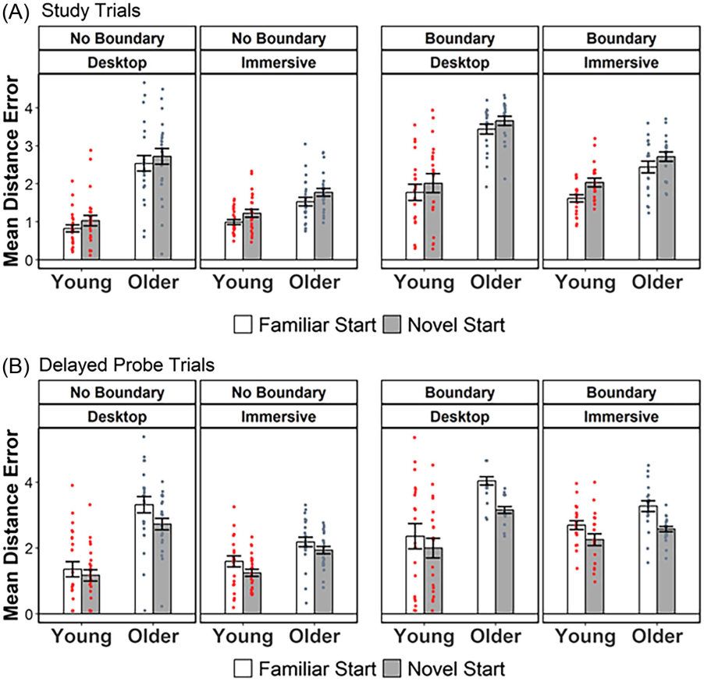
This document is copyrighted by the American Psychological Association or one of its allied publishers.
This article is intended solely for the personal use of the individual user and is not to be disseminated broadly.
All rights, including for text and data mining, AI training, and similar technologies, are reserved.

Note. (A) On study trials, distance error was greater when starting from a novel position. The size of this effect was not moderated by age group, virtual reality condition, or cue type. (B) On delayed probe trials, distance error was greater when starting from a familiar position. This effect was signiﬁcantly larger in the absence of the boundary cue. Likewise, age differences in the magnitude of these novel-to-familiar switching costs were signiﬁcant in the desktop virtual reality condition, but not when navigating in the immersive virtual reality environment. See the online article for the color version of this ﬁgure.

in the no-boundary condition, t(84) = −4.67, p < .001, BF10 = 248.893, along with a null effect of age in the boundary condition, t(84) = −1.89, p = .062, BF10 = 1.421. The interaction between age group and VR condition was not signiﬁcant in the desktop VR condition, F(1,84) = 0.61, p = .436, partial η2 = .007, and post hoc tests conﬁrmed that the effect of age was highly signiﬁcant in both the boundary, t(84) = −4.94, p < .001, and no-boundary, t(84) = −5.66, p < .001, desktop VR conditions. Although they should be interpreted cautiously, these results suggest that the presence of the perimeter boundary mitigated the tendency of older adults to replicate a previously learned path when navigating from a novel start location, but only in the immersive VR condition.

Older Adults Orient Toward Landmarks as Effectively as Younger Adults but Show Greater Angular Error When Orientating Toward the Hidden Target

We next examined whether older adults were impaired at using the distal landmarks to navigate. To this end, we examined whether young and older adults differed in their relative tendency to orient in

the direction of the distal mountain cues during the delayed probe trials (i.e., landmark error, see the Analytic Approach section). Landmark error was numerically but not signiﬁcantly lower in older adults (M = 0.29 radians, 95% HPD 0.25–0.35) compared with young adults (M = 0.36 radians, 95% HPD 0.30–0.42). Landmark error did not signiﬁcantly differ between the immersive (M = 0.28
radians, 95% HPD 0.24–0.32) and desktop (M = 0.38 radians, 95% HPD 0.32–0.45) VR conditions or between the boundary (M = 0.35
radians, 95% HPD 0.30–0.45) and no-boundary (M = 0.30 radians,
95% HPD 0.25–0.35) conditions. These ﬁndings suggest that older adults were able to orient to each of the four landmarks comparably with young adults.
We next considered how young and older adults might orient differently toward the hidden targets. Consistent with past reports of greater spatial distance error in older adults when locating hidden targets (Hill et al., 2024; McAvan et al., 2021), angular target error was reliably lower in young adults (M = 0.55 radians, 95% HPD 0.45–0.66) compared with older adults (M = 1.02 radians, 95% HPD 0.79–1.32). Angular target error was also lower in the boundary condition (M = 0.44 radians, 95% HPD 0.37–0.52) compared with

AGING AND SPATIAL NAVIGATION STRATEGIES 921

Figure 3
Path Replication During Spatial Learning

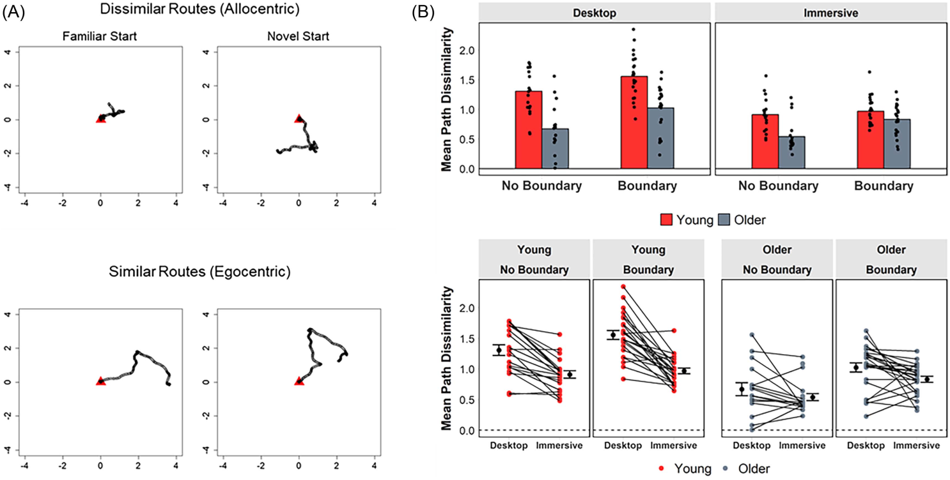

Note. (A) Example routes taken on consecutive trials initiated from a well-learned and familiar start position (left panels) and a novel start position (right panels). The paths were realigned to create a common starting coordinate. The top row illustrates high path dissimilarity, which is indicative of an allocentric strategy. The bottom row illustrated highly similar paths, which is indicative of an egocentric strategy. (B) Bar plot (top panel) illustrating the effect of age group on mean path distance (i.e., path dissimilarity) separately for virtual reality (VR) condition and cue type. Age differences in path similarity were signiﬁcantly attenuated in the immersive VR condition compared with the desktop VR condition. The spaghetti plots (bottom panel) emphasize that attenuated age effects in the immersive VR condition were driven by increased path similarity among young adults. See the online article for the color version of this ﬁgure.
This document is copyrighted by the American Psychological Association or one of its allied publishers.
This article is intended solely for the personal use of the individual user and is not to be disseminated broadly.
All rights, including for text and data mining, AI training, and similar technologies, are reserved.

the no-boundary condition (M = 1.32 radians, 95% HPD 1.00–
1.63). Target errors in the immersive (M = 0.66 radians, 95% HPD 0.54–0.79) and desktop (M = 0.82 radians, 95% HPD 0.61–1.01) VR conditions did not reliably differ, as indicated by overlapping
95% HPD intervals. These ﬁndings suggest that older adults per- formed worse at orienting toward the target, although this did not appear to relate to an inability to orient toward the landmarks.

Older Adults Do Not Show a Selective Tendency to Rely on a Single Landmark Compared With Young Adults

External landmarks can often act as reference points or “beacons” when located near a goal location. Navigating toward these ﬁxed landmarks moves the navigator closer to the goal location without placing any explicit demands on egocentric stimulus-motor asso- ciations or more abstracted allocentric representations (Waller &
Lippa, 2007; Wiener et al., 2013). Although young and older adults did not differ in their tendency to orient toward the distal landmarks, the above analyses do not rule out the possibility that older adults were over reliant on using a single landmark to navigate (beacon
strategy) rather than triangulating spatial positions based on multiple landmarks (allocentric strategy) (see Wiener et al., 2013). To address this possibility, we rotated the single distal mountain cue with the angular orientation closest to that of the hidden target on a subset of the delayed probe trials. We reasoned that among those

participants relying on a single mountain cue to locate the hidden target, distance error would predictably rotate along with the moved mountain (Figure 4A). Alternatively, participants who triangulate their position using multiple distal mountain cues should be less affected by the single rotated mountain (see McAvan et al., 2021).
The rotation indices for each age group and cue type are illus- trated in Figure 4B. A two-way ANOVA with factors of age group
(young, older) and cue type (boundary, no boundary) showed no signiﬁcant main effect of age group, F(1,81) = 0.48, p = .493, partial η2 = .006, BF10 = .272, as well as a nonsigniﬁcant Age Group × Cue Type interaction, F(1,81) = 0.53, p = .468, partial η2 = .007, BF10 =
.362. These ﬁndings suggest that older adults did not rely on a single mountain cue to a greater extent than young adults. The main effect of cue type was also not signiﬁcant, F(1,81) = 0.87, p = .353, partial η2 = .011, BF10 = 1.25, though the Bayes value suggested weak or
“anecdotal” evidence for the alternative hypothesis.
To further explore the effects of the rotated mountain cue, we performed one-sample t tests (two-tailed) to compare rotation indices against a hypothetical mean of 0.50 separately for each age group and cue type. Values at or below 0.5 would suggest a ten- dency to use a single landmark to a greater extent than the collection of the three landmarks. Error indices were signiﬁcantly greater than 0.50 among older adults in the boundary condition (M = 0.52, SD =
0.04), t(22) = 2.38, p = .026, suggesting a potential greater reliance on an allocentric strategy. Rotation indices in young adults did not

922

HILL ET AL.

Figure 4
Rotated Mountain Trials

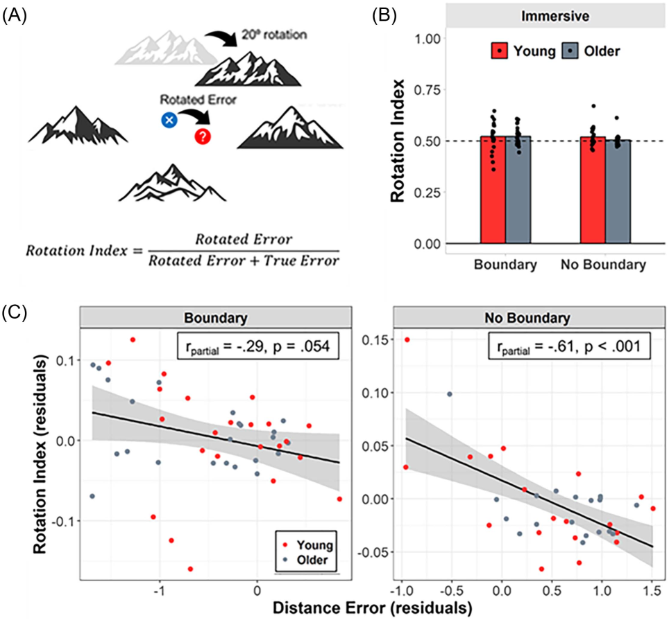
This document is copyrighted by the American Psychological Association or one of its allied publishers.
This article is intended solely for the personal use of the individual user and is not to be disseminated broadly.
All rights, including for text and data mining, AI training, and similar technologies, are reserved.

Note. (A) A singular distal mountain cue was rotated 20° clockwise or counterclockwise on a subset of the delayed probe trials. The blue and red dots indicate the actual and hypothetical rotated location of the hidden target, respectively. (B) Rotation indices did not signiﬁcantly differ between age groups or cue types. (C) Rotation indices negatively covaried with distance errors estimated during the delayed probe trials. This negative association was moderated by cue type, with a stronger negative association observed in the no-boundary condition compared with the boundary condition. See the online article for the color version of this ﬁgure.

signiﬁcantly differ from 0.5 in either of the cue type conditions,
boundary: M = 0.52, SD = 0.07, t(22) = 1.50, p = .148; no
boundary: M = 0.52, SD = 0.05, t(18) = 1.68, p = .110, nor did they differ from 0.5 among older adults in the no-boundary condition
(M = 0.50, SD = 0.03), t(19) = 0.52, p = .607. These results suggest
that, although young and older adults show a relatively equal weighting of the rotated and unmoved mountain cues, older adults might show a slight preference for using multiple stationary landmarks when additional boundary cues are also present.

Individual Differences in Reliance on Multiple Landmarks Relate to the Precision of Remembering the Hidden Target Independent of Age

In a ﬁnal set of analyses, we examined whether individual dif- ferences in rotation indices were related to the precision of spatial memories for target locations during the nonrotated delayed probe trials. We reasoned that those who rely more heavily on the collection of unmoved landmarks to orient within the environment (allocentric strategy) would be able to remember target locations more precisely

than those who relied more heavily on a single rotated cue (beacon strategy). To test this idea, we performed a multiple regression analysis with mean distance error on the delayed probe trials as the dependent variable and rotation indices, age group, cue type, and the respective two- and three-way interaction terms as independent variables. This analysis revealed a signiﬁcant negative linear rela- tionship between distance error and rotation indices (β = −8.63), F(1,77) = 28.23, p = 1.0−6. Critically, the interaction between age group and rotation indices was not signiﬁcant, F(1,77) = 0.79, p =
.378. This pattern of results suggests that, regardless of age, parti- cipants who were more likely to use multiple unmoved mountains to locate the hidden target on rotated probe trials generally performed better on the nonrotated delayed probe trials.
We also found a signiﬁcant interaction between rotation indices and cue type, F(1,81) = 4.67, p = .034. To unpack these results further, we computed partial correlations between distance error and rotation indices separately for the boundary and no-boundary conditions while controlling for age group (Figure 4C). This revealed a robust and signiﬁcant negative correlation between distance error and rotation indices in the no-boundary condition (rpartial = −.61,

AGING AND SPATIAL NAVIGATION STRATEGIES 923
This document is copyrighted by the American Psychological Association or one of its allied publishers.
This article is intended solely for the personal use of the individual user and is not to be disseminated broadly.
All rights, including for text and data mining, AI training, and similar technologies, are reserved.

p = 3.3−5). A nonsigniﬁcant negative correlation was also evident in the boundary condition that was comparatively weaker than that observed in the no-boundary condition (rpartial = −.29, p = .054). In other words, those who relied on multiple mountains to a greater extent when the boundary was present did not show the same advantage when ﬁnding the target compared with trials on which the boundary was not present.

Discussion

To test the hypothesis that older adults have a selective deﬁcit in allocentric navigation, we examined spatial strategies in a sample of young and older adults as they navigated a virtual MWM envi-
ronment. This paradigm has a long history of being used to examine spatial strategies and age-related differences in spatial memory in rodents (Barnes et al., 1980; Gallagher et al., 2015). Studies using virtual adaptations of the MWM in humans suggest that older adults often experience navigation difﬁculties. This is often suggested to be linked to a selective deﬁcit in hippocampal-mediated allocentric wayﬁnding strategies, which is frequently accompanied by a shift toward a preference for egocentric-based navigation strategies in older age (Colombo et al., 2017; Li & King, 2019). It bears special mention, however, that egocentric and response-based strategies have been conﬂated in some past studies of the MWM, and debate remains regarding the extent to which allocentric and egocentric measures can be cleanly dissociated (Ekstrom et al., 2014; Johnsen
& Rytter, 2021). In the present study, we considered multiple measures of putative allocentric and egocentric navigation to reduce the potential inﬂuence of this confound and isolate the speciﬁc factors that might best account for age differences in navigation performance. Moreover, the design of our experimental conditions allowed us to test whether age differences in navigation performance are differ- entially affected by the inclusion of geometric spatial cues (boundary vs. no boundary) and/or idiothetic sensorimotor cues (immersive VR vs. desktop VR).
Evidence for age differences in putative allocentric versus ego- centric navigation preferences was mixed. Young and older adults did not differ when navigating from a novel start location compared with a familiar start location on the spatial acquisition trials. The two age groups also did not differ when using distal landmarks to guide navigation during the delayed probe trials. However, older adults were more likely than younger individuals to replicate previously learned paths when navigating from a novel start position, consistent with a preference for familiar routes and egocentric navigation. The size of this age effect, however, was signiﬁcantly attenuated in the immersive version of the task, particularly when a circular boundary cue was included within the environment. Taken together, our re- sults suggest that the effects of age on spatial navigation are complex and cannot be fully explained in terms of a simple “deﬁcit” in allocentric navigation.
The clearest evidence in support of an age-related preference for egocentric strategy use was observed with our path replication analyses. Older adults were more likely than young adults to replicate a well-learned path when switching between familiar and novel start positions. As described in the foregoing paragraph, however, these age differences were signiﬁcantly attenuated when tested in the immersive VR condition, particularly when a boundary cue was present. Interestingly, this age effect was driven by younger individuals. Whereas older adults did not reliably differ

between the two VR conditions, young adults were more likely to replicate a previously learned path in the immersive version of the task, when the full range of ambulatory cues was available (see Figure 3, bottom panel). Body-based cues have been suggested to exert a disproportionate inﬂuence on egocentric tasks that require monitoring one’s own position in space (Huffman & Ekstrom, 2021; Tuena et al., 2022). The enriched ambulatory cues in the immersive VR condition may have biased young adults toward repeating more familiar paths when navigating to the hidden target locations. An alternative (though not mutually exclusive) possi- bility is that young adults were more likely to adopt landmark- dependent strategies when navigating in the absence of body-based cues in the desktop VR environment, resulting in a greater tendency to navigate novel paths when starting from a new start position. Though speculative, this interpretation is consistent with our obser- vation that landmark error was reliably reduced in the primarily visual desktop VR condition compared with the ambulatory immersive VR condition (see Figure 5A).
It is not readily apparent why path replication in older adults was not similarly affected by VR modality. One possibility is that the inﬂuence of body-based cues on egocentric strategy preferences is weakened in older age, potentially due to reduced sensorimotor acuity or changes in gait patterns and functional mobility (Hill &
Ekstrom, 2025). Alternatively, older adults may have been less likely than young individuals to navigate novel paths in the desktop VR condition due to a comparative lack of computer ﬂuency and gaming experience (Charness & Boot, 2022; Hill et al., 2024). However, another possibility is that age differences in path rep- lication reﬂect a general failure in older adults to accurately update their spatial position orientation toward ﬁxed landmarks when navigating from a novel location (Merhav & Wolbers, 2019; Rosenzweig et al., 2003). Nevertheless, the path replication analysis suggests that older adults were more likely than their younger counterparts to stick with a familiar route in both VR conditions, even when doing so was less efﬁcient and more likely to result in spatial errors (i.e., when navigating from a novel start position). We caution, however, that this pattern of results should not be taken to infer a selective deﬁcit in allocentric navigation, per se. Instead, these results may simply reﬂect a deﬁcit in spatial updating or a preference for taking the more familiar, albeit less efﬁcient, path.
Allocentric wayﬁnding strategies are typically evaluated based on the ability to use novel paths and shortcuts to reach a spatial goal.
Critically, these novel paths are almost always designed to offer a more efﬁcient alternative to taking a familiar but less direct route to reach the same goal. As a consequence, most experimental paradigms conﬂate path familiarity with path inefﬁciency. This represents a critical and often overlooked confound in studies assessing age- related differences in allocentric/egocentric navigation. Older adults are generally more risk averse than young adults and are more likely to engage in familiarity-seeking behaviors to avoid more uncertain outcomes (Albert & Duffy, 2012; Frank & Seaman, 2023; Spreng & Turner, 2021). Thus, behaviors that resemble allocentric deﬁcits in older age may simply reﬂect a preference for more familiar and predictable routes. Developing novel experimental methods to dissociate between path familiarity and efﬁciency is necessary to adjudicate between these respective sources of navigation errors in older age.
During the delayed probe trials, both young and older adults showed an advantage when recalling the hidden target from a novel

924

HILL ET AL.

Figure 5
Heading Error at Retrieval

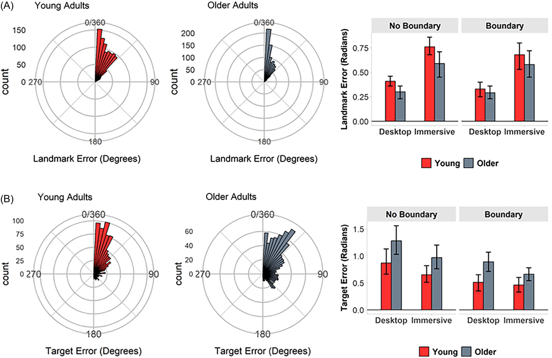
This document is copyrighted by the American Psychological Association or one of its allied publishers.
This article is intended solely for the personal use of the individual user and is not to be disseminated broadly.
All rights, including for text and data mining, AI training, and similar technologies, are reserved.

Note. Angular distance between participant heading and (A) distal mountain landmarks and (B) hidden target location at the time a memory response was made during the delayed probe trials. The polar histograms in the left panels illustrate the distribution of landmark and target error (in degrees) collapsed across the virtual reality conditions and cue types. The bar plots in the right panels illustrate the circular means of landmark and target error (in radians) separately for each age group, virtual reality condition, and cue type. The error bars represent the 95% higher posterior density derived from the circular mixed-effects regression models. See the online article for the color version of this ﬁgure.

compared with a familiar start location. This novelty advantage was signiﬁcantly greater in older adults compared with younger individuals when navigating in the desktop VR environment. The two age groups did not signiﬁcantly differ, however, when navigating in the im- mersive VR environment. We reported a similar novelty advantage in an independent sample of young and older adults navigating an immersive VR MWM similar to that reported here (McAvan et al., 2021). We note, however, that this prior study did not involve a direct comparison with desktop VR and, unlike the current paradigm, provided continuous visual feedback during the delayed probe trials, which may have enabled spatial updating during retrieval. One possibility is that navigating from novel locations introduced a degree of proactive interference, resulting in less precise spatial memory retrieval when navigating from familiar locations that were encoun- tered during the spatial acquisition period. In other words, participants may have updated their spatial representations when tested from novel locations, and this may have interfered with spatial memories that were encoded during the spatial acquisition period. At present, the reasons for this effect are unclear, and additional work is necessary to replicate and further parse the source of this novelty advantage.

Impaired spatial navigation in older age has also been proposed to stem from inefﬁciencies in using discrete landmarks to learn and subsequently navigate spatial environments (Colmant et al., 2023; West et al., 2023). This form of “landmark-dependent” navigation is often suggested to rely on hippocampal-mediated allocentric com- putations (Lester et al., 2017; Li & King, 2019). To examine whether older adults were less efﬁcient than young adults at using the distal landmarks, we computed the angular distance between participant heading at the time a memory response was made on the delayed probe trials and the heading of the closest distal mountain cue. Critically, young and older adults did not signiﬁcantly differ in their tendency to orient toward one of the distal landmarks, with older adults even showing a slight numerical advantage. Moreover, both age groups were more likely to orient toward the distal mountain cue than the actual location of the hidden target.
It is worth noting, however, that the statistically equivalent or- ienting to landmarks in young and older adults does not rule out the possibility that older adults were simply relying on a single distal cue as a beacon to guide spatial memory. To address this possibility, we rotated the distal mountain cue closest to the hidden target

AGING AND SPATIAL NAVIGATION STRATEGIES 925
This document is copyrighted by the American Psychological Association or one of its allied publishers.
This article is intended solely for the personal use of the individual user and is not to be disseminated broadly.
All rights, including for text and data mining, AI training, and similar technologies, are reserved.

location on a subset of the delayed probe trials. We reasoned that those using a beacon strategy would rotate their memory response commensurate to the rotation of the distal landmark. Spatial per- formance on the rotated mountain trials did not differ between young and older adults, suggesting that neither age group was more likely to rely single landmark during navigation. Moreover, per- formance on the rotated mountain trials predicted spatial distance error on the delayed probe trials, and this association was inde- pendent of age. Taken together, our results suggest that observed age differences in spatial memory could not be explained solely in terms of a deﬁcit in landmark-dependent navigation (cf. Colmant et al., 2023; West et al., 2023).
It has been proposed that healthy older adults may preferentially rely on geometric spatial cues over discrete landmarks to navigate.
Indeed, recent studies suggest that age differences in allocentric navigation are eliminated when geometric cues, such as environ- mental boundaries, are available to guide navigation (Bécu et al., 2020, 2023). We tested this idea by having a subset of young and older adult participants navigate a version of the MWM environ- ment that included a circular boundary wall, which served as a geometric cue. Young and older adults were less likely to replicate familiar paths when navigating from a novel start location in the boundary condition compared with the no-boundary condition. That
is, both age groups were less likely to replicate a previously learned path when geometric spatial cues were included within the envi-
ronment. We also note that, within the immersive VR condition, age differences in path replication were eliminated in the boundary
condition. We caution that this analysis was exploratory and should thus be interpreted cautiously. Nevertheless, the pattern is largely consistent with prior studies that suggest age differences in allo- centric-based navigation strategies are attenuated when geometric cues are available to guide navigation (Bécu et al., 2020, 2023; see also Hill, 2023).
Inclusion of the boundary wall did not affect the tendency to orient toward the discrete landmarks, regardless of age or VR condition (Figure 5A, right panel). This result contrasts with ﬁndings from a recent eye-tracking study that reported older adults spent less time ﬁxating on landmarks when geometric cues were present
(Bécu et al., 2023). We note that the circular boundary cue in our study—which was selected to mimic the circular enclosures often present in rodent (Eichenbaum et al., 1990; Gallagher et al., 2015; Morris et al., 1982) and human (Daugherty et al., 2015; Gazova et
al., 2013; Iggena et al., 2023; Moffat et al., 2006) adaptations of the MWM—differed from the types of asymmetric geometry cues used in prior studies, such as the Y-maze (Bécu et al., 2023) and rectangular enclosures (Bécu et al., 2023). Asymmetries in the angles and lengths of rectangular boundaries convey both directional and distance information, which may have been sufﬁcient to guide navigation even in the absence of discrete landmark cues. By contrast, the circular wall and distal mountain cues used in our study provided distinct yet complementary information about the environment. The distal mountain cues could be used to infer relative directions within the otherwise sparse environment but were too far (∼750 m) to allow for distance estimations. The circular boundary wall, while direc- tionally uninformative, could be used to estimate relative distances within the navigable arena.
One possibility is that young and older adults use a combination of landmark and geometric cues to orient, but only when the respective

cues provide complementary information about the environment, as was the case in our boundary condition. This interpretation may explain the performance advantage observed in both age groups when navigating in the boundary condition, as indicated by reduced angular target error (Figure 5B, right panel) and spatial distance error (Hill et al., 2024) compared with the no-boundary condition. Consequently, reliance on any given spatial cue to guide behavior is likely lessened when alternative cues are also present to optimize spatial performance. This may account for our observation that the correlation between distance error (a proxy for optimal navigation performance) and landmark-guided orientation (as assessed on the rotated mountain trials) was signiﬁcantly weakened by the presence of a boundary wall in both young and older adults (Figure 4C).
The principal aim of the present study was to identify whether age differences in navigation strategies are affected by the modality of the virtual testing environment. Prior studies of aging and navigation in humans have relied overwhelmingly on experimental paradigms that assess wayﬁnding on desktop computers or mobile platforms
(Coutrot et al., 2018; Diersch & Wolbers, 2019). This type of
“desktop VR” approach offers several advantages, including relative ease of implementation, minimal space requirements, reduced need for specialized equipment, and compatibility with functional neuro- imaging environments, such as functional magnetic resonance imaging. Desktop VR is also effective when examining many of the purely cognitive phenomena that support successful navigation, such as spatial memory or landmark perception. A major limitation of desktop VR is its restriction of natural body-based movements and sensorimotor feedback (e.g., vestibular, proprioceptive, motor efference copy), which are critical for real-world navigation (Hill & Ekstrom, 2025; Plácido et
al., 2022). Furthermore, cross-sectional studies of navigation may be confounded by group differences in visuomotor dexterity and/or prior experience with computerized gaming equipment (Charness & Boot, 2022; Hill et al., 2024). The ability to freely walk and rotate one’s body in an immersive VR environment can provide a more ecologically valid platform for capturing dynamic cognitive and sensorimotor inter- actions during more naturalistic navigation behavior (Hill & Ekstrom, 2025) in a carefully controlled laboratory environment.
Nevertheless, we cannot rule out the possibility that age differ- ences in prior exposure to VR headsets and other forms of im- mersive media may have inﬂuenced the observed age differences in navigation strategies, particularly path replication. Factors such as the restricted ﬁeld of view (∼110° horizontal FoV in the VR headset
vs. ∼180° in real-world binocular vision) or mild discomfort from dizziness or eye strain may have disproportionately affected nav- igation performance in the older adult group. Examining spatial behavior in real-world contexts could help address some of the limitations of immersive VR. We note though that while this approach would offer the highest ecological validity, it would also sacriﬁce the experimental control and manipulation achievable when using immersive VR techniques in a controlled laboratory setting. We acknowledge that many of the foregoing interpretations are based on nonsigniﬁcant effects of age on allocentric navigation and that null results do not necessarily reﬂect the true absence of an effect. Follow-up studies are therefore necessary to independently replicate and validate our ﬁndings. We are encouraged, however, that the present ﬁndings are largely consistent with those reported by a previous study from our laboratory that failed to identify age differences in putative allocentric strategy preferences in a separate

926
This document is copyrighted by the American Psychological Association or one of its allied publishers.
This article is intended solely for the personal use of the individual user and is not to be disseminated broadly.
All rights, including for text and data mining, AI training, and similar technologies, are reserved.

HILL ET AL.

sample of young and older adults navigating in immersive VR
(McAvan et al., 2021). We also note that null effects of age on spatial strategy were typically supported by strong evidence for the null based on Bayesian statistics.
To summarize, spatial navigation is a complex and multifaceted behavior that draws on multiple parallel cognitive, sensory, and motor systems (Ekstrom & Hill, 2023). Past work has suggested that impaired spatial navigation in older age may arise primarily from an allocentric deﬁcit. As we have described above, however, allo- centric and egocentric navigation strategies are difﬁcult to isolate, and there is also growing evidence that allocentric and egocentric sensory signals elicited during navigation recruit partially over- lapping brain circuits (for review, see Wang et al., 2020), further complicating attempts to dichotomize these variables. Here, we show that older adults were more likely than young individuals to replicate a familiar path, even when this type of route-based ego- centric strategy was less efﬁcient and more likely to produce spatial
errors. This age difference was signiﬁcantly attenuated, however, when geometric and body-based motor and vestibular cues were available during navigation. Critically, we did not identify any evidence to suggest that spatial errors in older age stem from a failure to attend to stable landmarks within the environment, which is a key component of putative allocentric navigation. These results underscore the limitations of using a simple allocentric–egocentric dichotomy to explain the complexity of spatial behaviors observed in older age.

References

Albert,S.M.,&Duffy,J.(2012).Differencesinriskaversionbetweenyoung
and older adults. Neuroscience and Neuroeconomics, 2012(1), Article 3.
https://doi.org/10.2147/NAN.S27184
Barnes, C. A., Nadel, L., & Honig, W. K. (1980). Spatial memory deﬁcit in senescent rats. Canadian Journal of Psychology, 34(1), 29–39. https:// doi.org/10.1037/h0081022
Bécu, M., Sheynikhovich, D., Ramanoël, S., Tatur, G., Ozier-Lafontaine, A., Authié, C. N., Sahel, J.-A., & Arleo, A. (2023). Landmark-based spatial navigation across the human lifespan. eLife, 12, Article e81318. https:// doi.org/10.7554/eLife.81318
Bécu, M., Sheynikhovich, D., Tatur, G., Agathos, C. P., Bologna, L. L.,
Sahel, J.-A., & Arleo, A. (2020). Age-related preference for geometric spatial cues during real-world navigation. Nature Human Behaviour, 4(1), 88–99. https://doi.org/10.1038/s41562-019-0718-z
Benton, A. L. (1968). Differential behavioral effects in frontal lobe disease. Neuropsychologia, 6(1), 53–60. https://doi.org/10.1016/0028-3932(68) 90038-9
Bondi,M.W., Jak,A. J., Delano-Wood,L., Jacobson,M.W., Delis, D.C., &
Salmon, D. P. (2008). Neuropsychological contributions to the early identiﬁcation of Alzheimer’s disease. Neuropsychology Review, 18(1), 73–90. https://doi.org/10.1007/s11065-008-9054-1
Campbell, M. G., Ocko, S. A., Mallory, C. S., Low, I. I. C., Ganguli, S., &
Giocomo, L. M. (2018). Principles governing the integration of landmark and self-motion cues in entorhinal cortical codes for navigation. Nature Neuroscience, 21(8), 1096–1106. https://doi.org/10.1038/s41593-018-0189-y
Charness, N., & Boot, W. R. (2022). A grand challenge for psychology: Reducing the age-related digital divide. Current Directions in Psychological Science, 31(2), 187–193. https://doi.org/10.1177/09637214211068144
Colmant,L.,Bierbrauer,A.,Bellaali,Y.,Kunz,L.,VanDongen,J.,Sleegers,
K., Axmacher, N., Lefèvre, P., & Hanseeuw, B. (2023). Dissociating effects of aging and genetic risk of sporadic Alzheimer’s disease on path

integration. Neurobiology of Aging, 131, 170–181. https://doi.org/10
.1016/j.neurobiolaging.2023.07.025
Colombo, D., Serino, S., Tuena, C., Pedroli, E., Dakanalis, A., Cipresso, P.,
& Riva, G. (2017). Egocentric and allocentric spatial reference frames in
aging:Asystematic review.Neuroscience and Biobehavioral Reviews,80, 605–621. https://doi.org/10.1016/j.neubiorev.2017.07.012
Coutrot, A., Silva, R., Manley, E., De Cothi, W., Sami, S., Bohbot, V. D.,
Wiener, J. M., Hölscher, C., Dalton, R. C., Hornberger, M., & Spiers, H. J.
(2018). Global determinants of navigation ability. Current Biology, 28(17), 2861–2866. https://doi.org/10.1016/j.cub.2018.06.009
Cremers, J. (2020). bpnreg: Bayesian projected normal regression models for circular data (R package Version 2.0.1). https://CRAN.R-project.org/ package=bpnreg
Cremers, J., & Klugkist, I. (2018). One direction? A tutorial for circular data analysis using R with examples in cognitive psychology. Frontiers in Psychology, 9, Article 2040. https://doi.org/10.3389/fpsyg.2018
.02040
Cremers, J., Mulder, K. T., & Klugkist, I. (2018). Circular interpretation of regression coefﬁcients. British Journal of Mathematical and Statistical Psychology, 71(1), 75–95. https://doi.org/10.1111/bmsp.12108
Daugherty, A. M., & Raz, N. (2017). A virtual water maze revisited: Two- year changes in navigation performance and their neural correlates in healthy adults. NeuroImage, 146, 492–506. https://doi.org/10.1016/j.neu roimage.2016.09.044
Daugherty,A.M.,Yuan,P.,Dahle,C.L.,Bender,A.R.,Yang,Y.,&Raz,N.
(2015). Path complexity in virtual water maze navigation: Differential associations with age, sex, and regional brain volume. Cerebral Cortex, 25(9), 3122–3131. https://doi.org/10.1093/cercor/bhu107
Delis, D. C., Kramer, J. H., Kaplan, E., & Ober, B. A. (2000). California verbal learning test (2nd ed.). The Psychological Corportation.
Diersch, N., & Wolbers, T. (2019). The potential of virtual reality for spatial navigation research across the adult lifespan. Journal of Experimental Biology, 222(Suppl_1), jeb187252. https://doi.org/10
.1242/jeb.187252
Du, Y. K., McAvan, A. S., Zheng, J., & Ekstrom, A. D. (2023). Spatial memory distortions for the shapes of walked paths occur in violation of physically experienced geometry. PLOS ONE, 18(2), Article e0281739.
https://doi.org/10.1371/journal.pone.0281739
Eichenbaum, H., Stewart, C., & Morris, R. G. (1990). Hippocampal representation in place learning. The Journal of Neuroscience, 10(11), 3531–3542. https://doi.org/10.1523/JNEUROSCI.10-11-03531.1990
Ekstrom, A. D., Arnold, A. E. G. F., & Iaria, G. (2014). A critical review of the allocentric spatial representation and its neural underpinnings: Toward a network-based perspective.Frontiers in Human Neuroscience,8,Article
803. https://doi.org/10.3389/fnhum.2014.00803
Ekstrom, A. D., & Hill, P. F. (2023). Spatial navigation and memory: A review of the similarities and differences relevant to brain models and age. Neuron, 111(7), 1037–1049. https://doi.org/10.1016/j.neuron.20 23.03.001
Frank, C. C., & Seaman, K. L. (2023). Aging, uncertainty, and decision making—A review. Cognitive, Affective & Behavioral Neuroscience, 23(3), 773–787. https://doi.org/10.3758/s13415-023-01064-w
Gallagher, M., Burwell, R., & Burchinal, M. (2015). Severity of spatial learning impairment in aging: Development of a learning index for per- formance in the Morris water maze. Behavioral Neuroscience, 129(4), 540–548. https://doi.org/10.1037/bne0000080
Gazova, I., Laczó, J., Rubinova, E., Mokrisova, I., Hyncicova, E., Andel, R.,
Vyhnalek, M., Sheardova, K., Coulson, E. J., & Hort, J. (2013). Spatial navigation in young versus older adults. Frontiers in Aging Neuroscience, 5, Article 94. https://doi.org/10.3389/fnagi.2013.00094
Giorgino, T. (2009). Computing and visualizing dynamic time warping alignments in R: The dtw package. Journal of Statistical Software, 31(7), 1–24. https://doi.org/10.18637/jss.v031.i07

AGING AND SPATIAL NAVIGATION STRATEGIES 927
This document is copyrighted by the American Psychological Association or one of its allied publishers.
This article is intended solely for the personal use of the individual user and is not to be disseminated broadly.
All rights, including for text and data mining, AI training, and similar technologies, are reserved.

Goodglass, H., Kaplan, E., & Barresi, B. (2001). The assessment of aphasia and related disorders. Lippincott Williams & Wilkins.
Greenhouse, S. W., & Geisser, S. (1959). On methods in the analysis of proﬁle data. Psychometrika, 24(2), 95–112. https://doi.org/10.1007/BF02 289823
Harris, M. A., Wiener, J. M., & Wolbers, T. (2012). Aging speciﬁcally impairs switching to an allocentric navigational strategy. Frontiers in Aging Neuroscience, 4, Article 29. https://doi.org/10.3389/fnagi.20 12.00029
Harris, M. A., & Wolbers, T. (2014). How age-related strategy switching deﬁcits affect wayﬁnding in complex environments. Neurobiology of Aging, 35(5), 1095–1102. https://doi.org/10.1016/j.neurobiolaging.2013
.10.086
Hill, P. F. (2023). When landmarks are not enough. eLife, 12, Article e87771.
https://doi.org/10.7554/eLife.87771
Hill, P. F. (2025). AgingNavigationVR_mountains2 [Data set]. Open Science Framework. https://doi.org/10.17605/OSF.IO/5VBZN
Hill, P. F., Bermudez, S., McAvan, A. S., Garren, J. D., Grilli, M. D., Barnes,
C. A., & Ekstrom, A. D. (2024). Age differences in spatial memory are mitigated during naturalistic navigation. Aging, Neuropsychology, and Cognition, 31(6), 1106–1130. https://doi.org/10.1080/13825585.2024
.2326244
Hill, P. F., & Ekstrom, A. D. (2025). A cognitive-motor framework for spatial navigation in aging and early-stage Alzheimer’s disease. Cortex, 185, 133–150. https://doi.org/10.1016/j.cortex.2025.02.003
Huffman, D. J., & Ekstrom, A. D. (2021). An important step toward understanding the role of body-based cues on human spatial memory for large-scale environments. Journal of Cognitive Neuroscience, 33(2), 167–
179. https://doi.org/10.1162/jocn_a_01653
Iaria, G., Palermo, L., Committeri, G., & Barton, J. J. S. (2009). Age differences in the formation and use of cognitive maps. Behavioural Brain Research, 196(2), 187–191. https://doi.org/10.1016/j.bbr.2008.08.040
Iaria, G., Petrides, M., Dagher, A., Pike, B., & Bohbot, V. D. (2003). Cognitive strategies dependent on the hippocampus and caudate nucleus in human navigation: Variability and change with practice. The Journal of Neuroscience, 23(13), 5945–5952. https://doi.org/10.1523/JNEUROSCI
.23-13-05945.2003
Iggena, D., Jeung, S., Maier, P. M., Ploner, C. J., Gramann, K., & Finke, C.
(2023). Multisensory input modulates memory-guided spatial navigation in humans. Communications Biology, 6(1), Article 1167. https://doi.org/ 10.1038/s42003-023-05522-6
Jak, A. J., Bondi, M. W., Delano-Wood, L., Wierenga, C., Corey-Bloom, J., Salmon, D. P., & Delis, D. C. (2009). Quantiﬁcation of ﬁve neuropsy- chological approaches to deﬁning mild cognitive impairment. The American Journal of Geriatric Psychiatry, 17(5), 368–375. https://doi.org/10.1097/ JGP.0b013e31819431d5
Jeffreys, H. (1961). Theory of probability (3rd ed.). Oxford University Press.
Johnsen, S. H. W., & Rytter, H. M. (2021). Dissociating spatial strategies in
animal research: Critical methodological review with focus on egocentric
navigation and the hippocampus. Neuroscience and Biobehavioral
Reviews, 126, 57–78. https://doi.org/10.1016/j.neubiorev.2021.03.022
Kolarik, B. S., Baer, T., Shahlaie, K., Yonelinas, A. P., & Ekstrom, A. D.
(2018). Close but no cigar: Spatial precision deﬁcits following medial temporal lobe lesions provide novel insight into theoretical models of navigation and memory. Hippocampus, 28(1), 31–41. https://doi.org/10
.1002/hipo.22801
Lenth, R. (2018). Emmeans: Estimated marginal means, aka least-squares means. R Package Version 1.3.0. https://CRAN.R-project.org/package=e mmeans
Lester, A. W., Moffat, S. D., Wiener, J. M., Barnes, C. A., & Wolbers, T.
(2017). The aging navigational system. Neuron, 95(5), 1019–1035. https:// doi.org/10.1016/j.neuron.2017.06.037

Li, A. W. Y., & King, J. (2019). Spatial memory and navigation in ageing: A systematic review of MRI and fMRI studies in healthy participants. Neuroscience and Biobehavioral Reviews, 103, 33–49. https://doi.org/10
.1016/j.neubiorev.2019.05.005
McAvan, A. S., Du, Y. K., Oyao, A., Doner, S., Grilli, M. D., & Ekstrom, A.
(2021). Older adults show reduced spatial precision but preserved strat- egy-use during spatial navigation involving body-based cues. Frontiers in Aging Neuroscience, 13, Article 640188. https://doi.org/10.3389/fnagi
.2021.640188
Merhav, M., & Wolbers, T. (2019). Aging and spatial cues inﬂuence the updating of navigational memories. Scientiﬁc Reports, 9(1), Article 11469.
https://doi.org/10.1038/s41598-019-47971-2
Moffat, S. D., Elkins, W., & Resnick, S. M. (2006). Age differences in the neural systems supporting human allocentric spatial navigation. Neurobiology of Aging, 27(7), 965–972. https://doi.org/10.1016/j.neuro biolaging.2005.05.011
Moffat, S. D., Kennedy, K. M., Rodrigue, K. M., & Raz, N. (2007). Extrahippocampal contributions to age differences in human spatial
navigation. Cerebral Cortex, 17(6), 1274–1282. https://doi.org/10.1093/ cercor/bhl036
Moffat, S. D., & Resnick, S. M. (2002). Effects of age on virtual environment place navigation and allocentric cognitive mapping. Behavioral Neuroscience, 116(5), 851–859. https://doi.org/10.1037/ 0735-7044.116.5.851
Morey, R. D., Rouder, J. N., Jamil, T., Urbanek, S., Forner, K., & Ly, A.
(2022). BayesFactor: Computation of Bayes factors for common designs.
https://richarddmorey.github.io/BayesFactor/
Morris, R. G. M., Garrud, P., Rawlins, J. N. P., & O’Keefe, J. (1982). Place navigation impaired in rats with hippocampal lesions. Nature, 297(5868), 681–683. https://doi.org/10.1038/297681a0
O’Keefe, J., & Nadel, L. (1978). The hippocampus as a cognitive map. Oxford University Press.
Plácido, J., de Almeida, C. A. B., Ferreira, J. V., de Oliveira Silva, F., Monteiro-Junior, R. S., Tangen, G. G., Laks, J., & Deslandes, A. C.
(2022). Spatial navigation in older adults with mild cognitive impairment and dementia: A systematic review and meta-analysis. Experimental Gerontology, 165, 111852. https://doi.org/10.1016/j.exger.2022.111852 R Core Team. (2022). R: A language and environment for statistical computing. R Foundation for Statistical Computing. http://www.R-proje
ct.org/
Reitan, R. M., & Wolfson, D. (1985). The Halstead-Reitan neuropsychological test battery: Therapy and clinical interpretation. Neuropsychology Press.
Rey, A. (1941). L’examen psychologique dans les cas d’encéphalopathie
traumatique. (Les problems.) [The psychological examination in cases of traumatic encepholopathy. Problems]. Archives de Psychologie, 28, 215–285.
Rosenzweig, E. S., Redish, A. D., McNaughton, B. L., & Barnes, C. A. (2003). Hippocampal map realignment and spatial learning. Nature Neuroscience, 6(6), 609–615. https://doi.org/10.1038/nn1053
Siegel, A. W., & White, S. H. (1975). The development of spatial representations of large-scale environments. Advances in Child Deve- lopment and Behavior, 10, 9–55. https://doi.org/10.1016/S0065-2407(08)60007-5
Singmann, H., Bolker, B., Westfall, J., & Aust, F. (2016). Afex: Analysis of factorial experiments (R package Version 0.22-1). https://CRAN.R-proje
ct.org/package=afex
Spreen, O., & Benton, A. L. (1977). Neurosensory center comprehensive examination for aphasia. Neuropsychology Laboratory.
Spreng, R. N., & Turner, G. R. (2021). From exploration to exploitation: A shifting mental mode in late life development. Trends in Cognitive Sciences, 25(12), 1058–1071. https://doi.org/10.1016/j.tics.2021.09
.001

928

HILL ET AL.

Starrett, M. J., McAvan, A. S., Huffman, D. J., Stokes, J. D., Kyle, C. T.,
Smuda, D. N., Kolarik, B. S., Laczko, J., & Ekstrom, A. D. (2021). Landmarks: A solution for spatial navigation and memory experiments in virtual reality. Behavior Research Methods, 53(3), 1046–1059. https:// doi.org/10.3758/s13428-020-01481-6
Tuena, C., Riva, G., Murru, I., Campana, L., Goulene, K. M., Pedroli, E., & Stramba-Badiale, M. (2022). Contribution of cognitive and bodily nav- igation cues to egocentric and allocentric spatial memory in hallucinations due to Parkinson’s disease: A case report. Frontiers in Behavioral Neuroscience, 16, Article 992498. https://doi.org/10.3389/fnbeh.2022
.992498
Waller, D., & Lippa, Y. (2007). Landmarks as beacons and associative cues: Their role in route learning. Memory & Cognition, 35(5), 910–924. https:// doi.org/10.3758/BF03193465
Wang, C., Chen, X., & Knierim, J. J. (2020). Egocentric and allocentric re- presentations of space in the rodent brain. Current Opinion in Neurobiology, 60, 12–20. https://doi.org/10.1016/j.conb.2019.11.005
Wechsler, D. (2009). Wechsler memory scale (4th ed.). The Psychological Corporation.
West, G. L., Patai, Z. E., Coutrot, A., Hornberger, M., Bohbot, V. D., &
Spiers, H. J. (2023). Landmark-dependent navigation strategy declines across the human life-span: Evidence from over 37,000 participants.

Journal of Cognitive Neuroscience, 35(3), 452–467. https://doi.org/10
.1162/jocn_a_01956
Wiener, J. M., de Condappa, O., Harris, M. A., & Wolbers, T. (2013). Maladaptive bias for extrahippocampal navigation strategies in aging
humans. The Journal of Neuroscience, 33(14), 6012–6017. https://doi.org/ 10.1523/JNEUROSCI.0717-12.2013
Wolbers, T., & Wiener, J. M. (2014). Challenges for identifying the neural mechanisms that support spatial navigation: The impact of spatial scale. Frontiers in Human Neuroscience, 8, Article 571. https://doi.org/10.3389/ fnhum.2014.00571
Zhong, J. Y., Magnusson, K. R., Swarts, M. E., Clendinen, C. A., Reynolds,
N. C., & Moffat, S. D. (2017). The application of a rodent-based Morris water maze (MWM) protocol to an investigation of age-related differences in human spatial learning. Behavioral Neuroscience, 131(6), 470–482.
https://doi.org/10.1037/bne0000219

Received October 31, 2024
Revision received June 20, 2025 Accepted June 23, 2025 ▪

This document is copyrighted by the American Psychological Association or one of its allied publishers.
This article is intended solely for the personal use of the individual user and is not to be disseminated broadly.
All rights, including for text and data mining, AI training, and similar technologies, are reserved.



Reproduced with permission of copyright owner. Further reproduction prohibited without permission.

